**SQL Order by Elapsed Time**

200

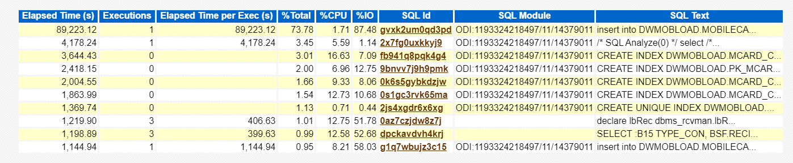

100

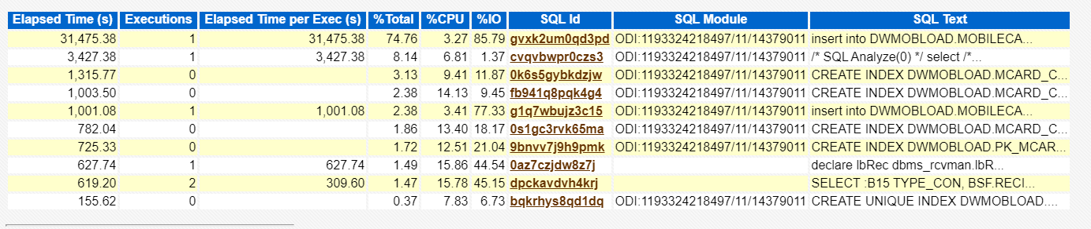

**SQL Order by CPU Time**

200

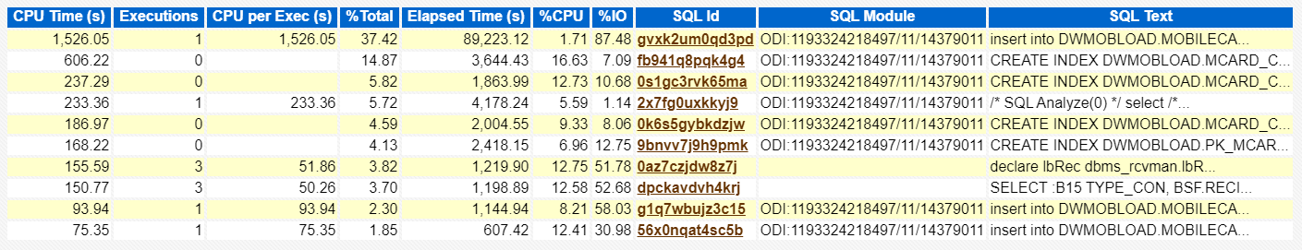

100

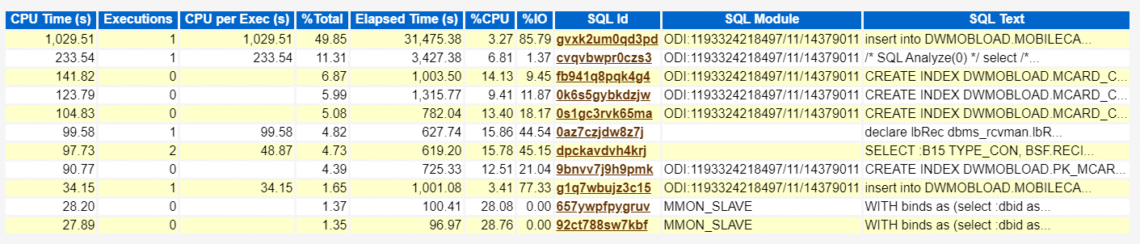

**SQL Order by User I/O WAIT Time**

200

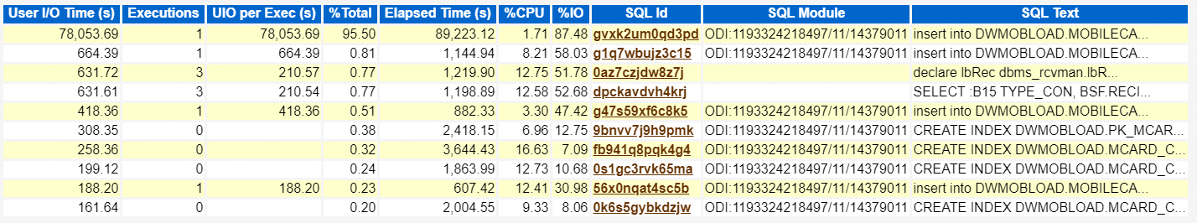

100

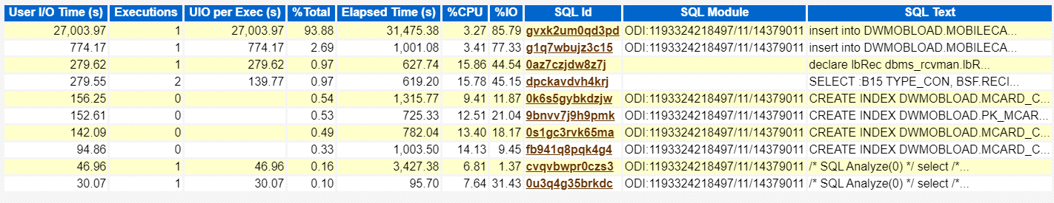

**SQL Order by Gets**

200

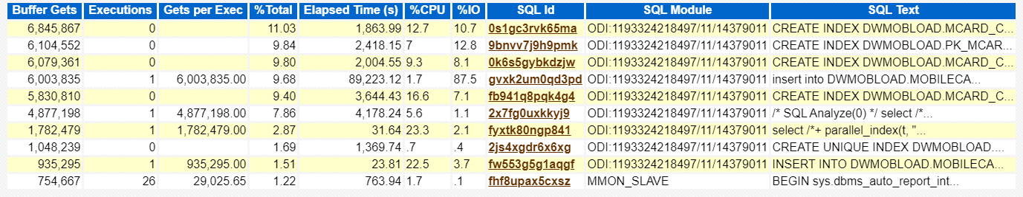

100

